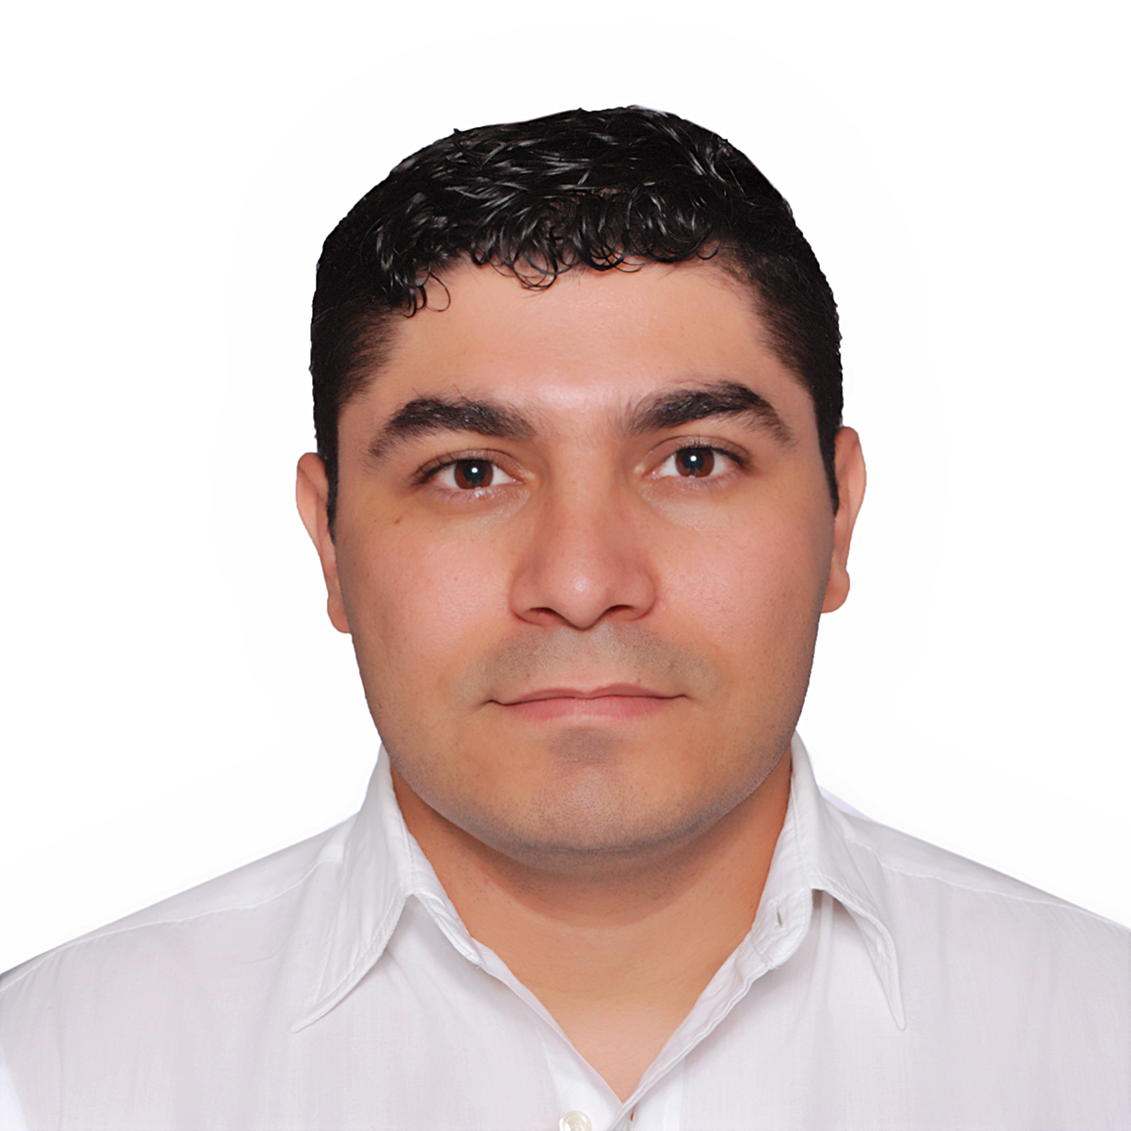

**Rossel Antonio Urbina Cardona**

Hondureña, 15/Sep/1988,

Colonia San Angel, Tegucigalpa, Honduras

rossel7urbina@gmail.com, (504) 33014237 & 22302695

**Objective**

Find an organization that will allow me to apply the knowledge acquired in the years of study, as well as my planning and control capacity. Being part of a team of work and consolidate professionally in a company, in addition to allow opportunities for personal and professional development.

**Education**

(02/2007) to (10/2009): Instituto Alfonzo Guillen Zelaya

Bachelor of Science and Letters

(02/2010) to (to date today): CEUTEC | University Technology Center

computer engineering intern. <http://www.ceutec.hn/>

**Work Experience**

(05/06/2016) to (01/08/2017) Waiter - ( Tony’s Mar)

(11-04-2018) to (07-14-2019) Restaurant Steward – Norwegian epic.

(09-22-2019) to (01-15-2020) Restaurant Steward – Norwegian epic.

(01-16-2020) to (02-06-2020) Assistant Waiter – Norwegian epic.

**Languages:** Spanish, English.

**Computer Skills: adobe** package, Microsoft suite, SQL server, java and .NET